

Perth Modern School

z

Semester One Examination, 2019

Question/Answer booklet

MATHEMATICS
UNIT

Section One:

Calculator-free

Your Name

Your Teacher’s Name

Time allowed for this section
Reading time before commencing work: five minutes
Working time: fifty minutes

Materials required/recommended for this section
To be provided by the supervisor
This Question/Answer booklet
Formula sheet

To be provided by the candidate
Standard items: pens (blue/black preferred), pencils (including coloured), sharpener, correction fluid/tape, eraser, ruler, highlighters

Special items: nil

Important note to candidates
No other items may be taken into the examination room. It is your responsibility to ensure that you do not have any unauthorised material. If you have any unauthorised material with you, hand it to the supervisor before reading any further.
Question | Mark | Max | Question | Mark | Max
1 |  | 6 | 5 |  | 9
2 |  | 5 | 6 |  | 7
3 |  | 6 | 7 |  | 7
4 |  | 10

Structure of this paper

Section | Number of questions available | Number of questions to be answered | Working  time (minutes) | Marks available | Percentage of exam
Section One:  Calculator-free | 7 | 7 | 50 | 50 | 35
Section Two:  Calculator-assumed | 14 | 14 | 100 | 105 | 65
 |  |  | Total | 155 | 100

Instructions to candidates

- The rules for the conduct of examinations are detailed in the school handbook. Sitting this examination implies that you agree to abide by these rules.

- Write your answers in this Question/Answer Booklet.

- You must be careful to confine your response to the specific question asked and to follow any instructions that are specified to a particular question.

- Spare pages are included at the end of this booklet. They can be used for planning your responses and/or as additional space if required to continue an answer.
- Planning: If you use the spare pages for planning, indicate this clearly at the top of the page.
- Continuing an answer: If you need to use the space to continue an answer, indicate in the original answer space where the answer is continued, i.e. give the page number. Fill in the number of the question that you are continuing to answer at the top of the page.

- Show all your working clearly. Your working should be in sufficient detail to allow your answers to be checked readily and for marks to be awarded for reasoning. Incorrect answers given without supporting reasoning cannot be allocated any marks. For any question or part question worth more than two marks, valid working or justification is required to receive full marks. If you repeat any question, ensure that you cancel the answer you do not wish to have marked.

- It is recommended that you do not use pencil, except in diagrams.

- The Formula Sheet is not to be handed in with your Question/Answer Booklet.

Section One: Calculator-free (50 Marks)
This section has seven (7) questions. Answer all questions. Write your answers in the spaces provided.

Working time for this section is 50 minutes.

Question 1 (6 marks)

- Differentiate $\frac{x}{e^{x}}$ and simplify using the quotient rule. (3 marks)

Solution
Specific behaviours
correct numerator
correct denominator
simplifies

- Hence, find the definite integral $\int_{0}^{1}{\frac{1-x}{{2e}^{x}} dx}$. (3 marks)

Solution
Specific behaviours
takes out factor of 1/2
uses fundamental theorem
uses limits correctly

Question 2 (5 marks)

Determine the area between the $x$-axis and the curve $y=2\cos\left(x\right)-1$for .
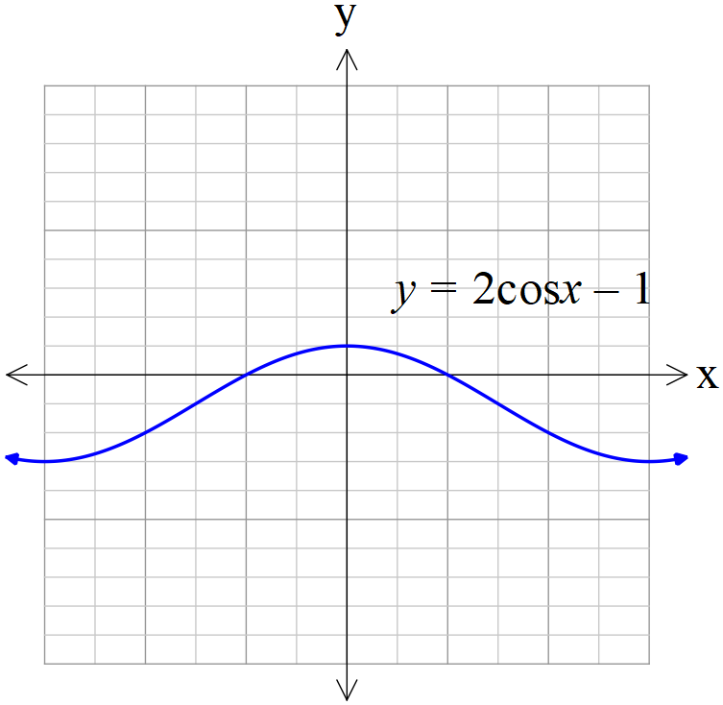
Solution
Specific behaviours
works in radians
determines exact x intercept
breaks into two integrals, above and below areas
integrates correctly
determines total area

Question 3 (6 marks)

Determine whether the following could be a probability density function on the given interval. Explain with reasons.

- $f\left(x\right)=\frac{2}{3} (x^{2}-x)$ $for the interval -1≤x≤2.$ (2 marks)

Solution

Quadratic is less than zero between x equal to zero and one hence not a pdf

Specific behaviours
states no with a reason
correct reason

- $f\left(x\right)=\left\{\begin{aligned} 3x^{2} for-1≤x≤0 \\ 0 otherwise\end{aligned}\right.$ (2 marks)

Solution

Yes as all positive with area equaled to one
Specific behaviours
states yes with a reason
correct reason

- . (2 marks)
Solution

No as f(x) is always negative

Specific behaviours
No with reason
correct reason

Question 4 (10 marks)

- Given that determine . (4 marks)
Solution
Specific behaviours
shows x & z in power expressions
shows y in power expressions
solves for two variables
determines x+y-z

- Solve for if $3\log_{3}\left(x\right)+\log_{3}\left(2x-1\right)- 2\log_{3}\left(x\right)=1$ (4 marks)

Solution
Specific behaviours
changes all three terms to 1log(term)
writes LHS as one log statement
changes to a power statement and obtains a quadratic equation for x
states one positive value of x

Question 5 (9 marks)
- Determine $f(t)$ if $f^{''}\left(t\right)=2e^{t}+3\sin\left(t\right)$ and $f\left(0\right)=0, f^{'}\left(0\right)=0.$ (4 marks)

Solution
Specific behaviours
integrates second derivative
solves for first constant
integrates first derivative
solves for second constant

- Evaluate (3 marks)

Solution
Specific behaviours
uses ln
shows derivation of 1/5
adds a constant

- Determine and simplify. (3 marks)
Solution
Specific behaviours
uses product rules
differentiates all terms correctly
factorises

Question 6 (7 marks)
Two very slow cars are positioned at time hours at the positions shown in the diagram below. Car A is moving North at 4 km/h while car B is moving West at 6 km/h.

- Show that the distance between the two cars at time hours is given by km. (2 marks)

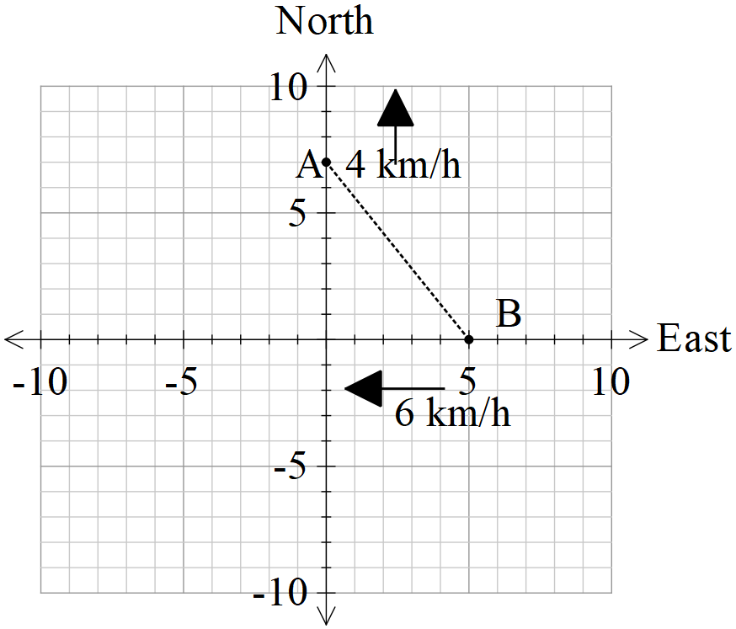
Solution
Specific behaviours
determines expressions for x and y at time t
uses Pythagoras

- Determine using calculus, the time in hours that the separation is a minimum.
Show that this is indeed a minimum. (5 marks)
Solution
Specific behaviours
attempts to differentiate and equates to zero
obtains derivative with correct denominator
obtains derivative with correct numerator
solves for t
uses first derivative test showing actual values

Question 7 (7 marks)
Sketch the graph of a continuous function $y=f\left(x\right)$ which satisfies all the following conditions:
- Domain of $f\left(x\right)$ is
- , ,
- for , for

Solution
Specific behaviours
non negative gradients between x values -10 & 7
two defined points
three defined points
horizontal inflection at x=-3
non stationary inflection at x=4
turning point at x=7
negative gradients for x>7

Additional working space

Question number: _________

